

**Project Members:**

•       **Muhammad Abdullah (53457)**

**Creating Schema User**

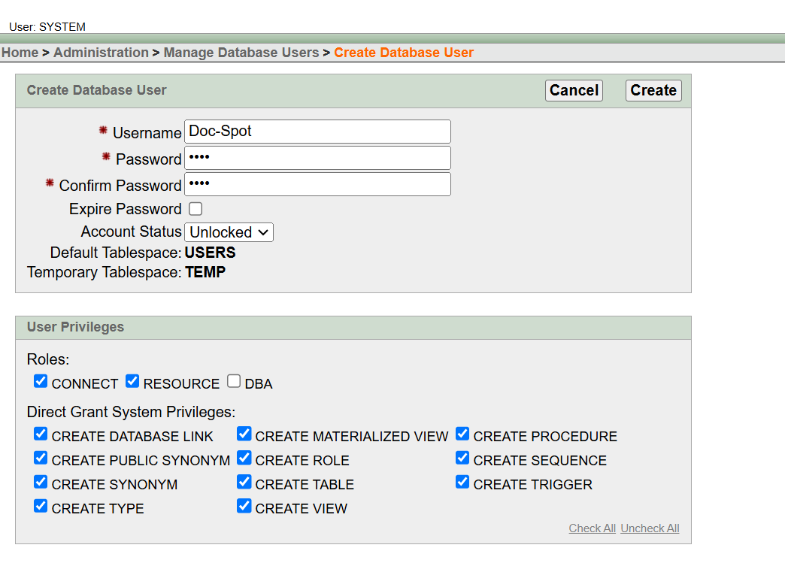

1. **Courses Table**

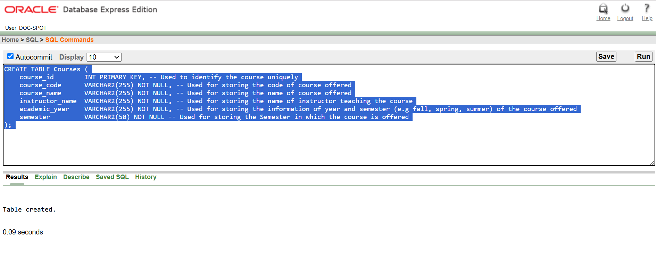

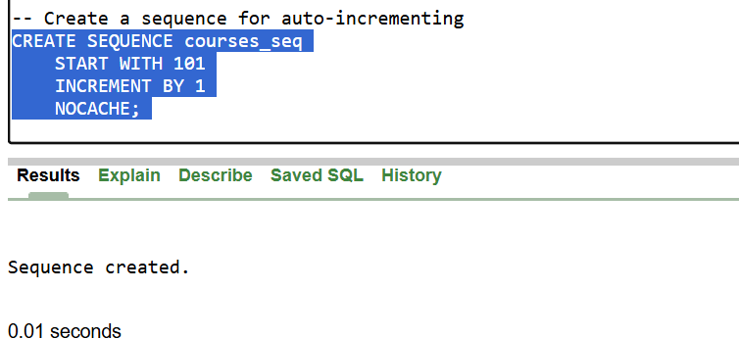

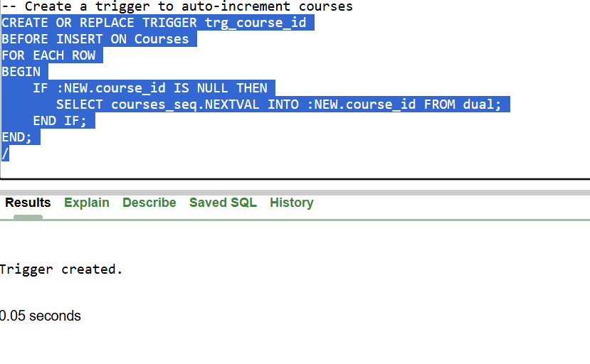

1. **University Table**

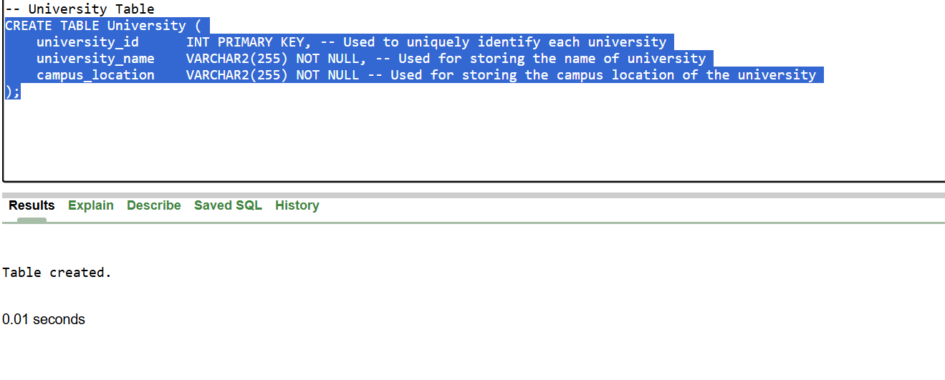

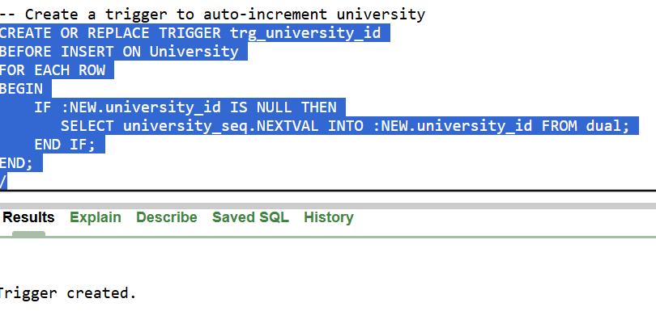

1. **Departments Table**

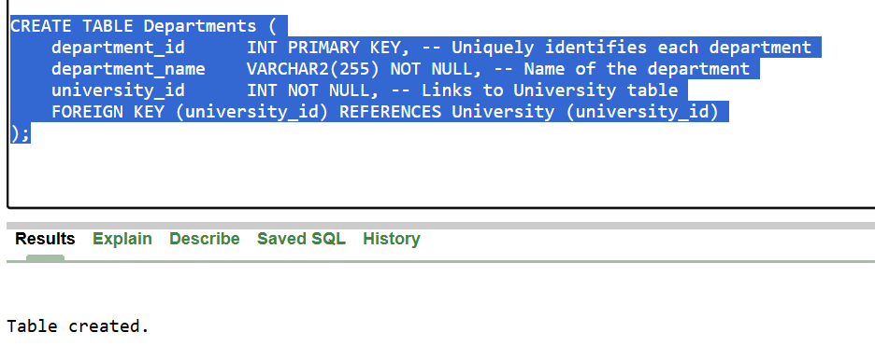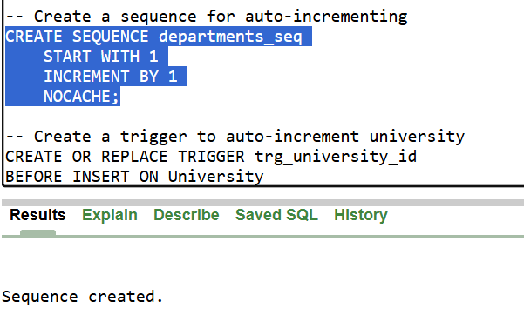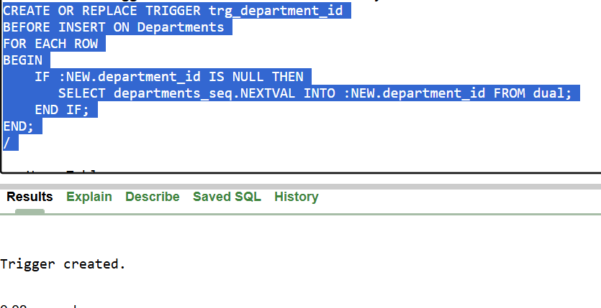

1. **Users Table**

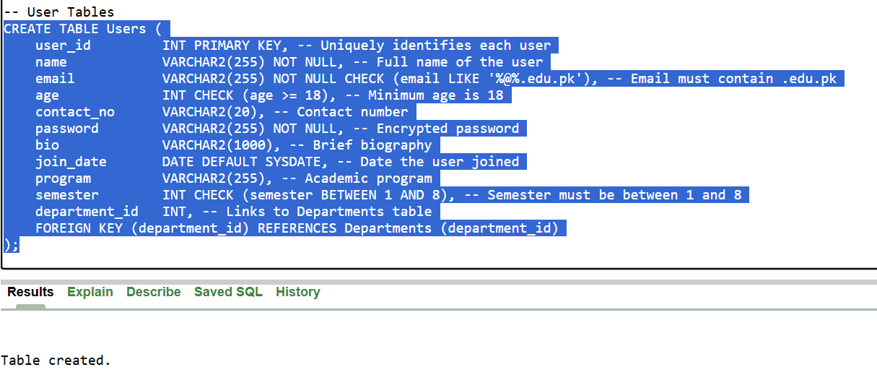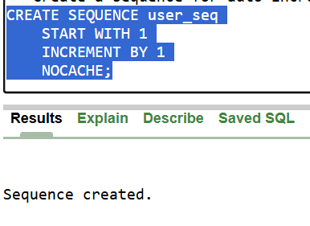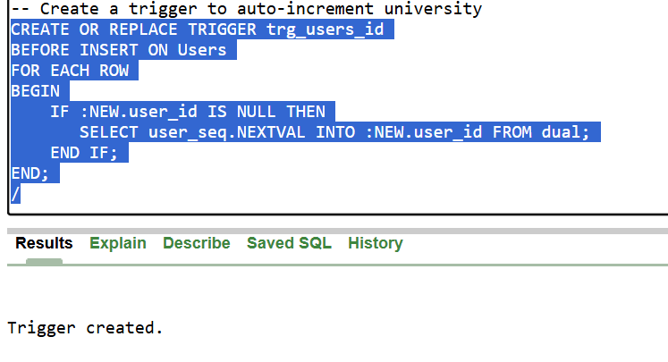

1. **Wallet Table**

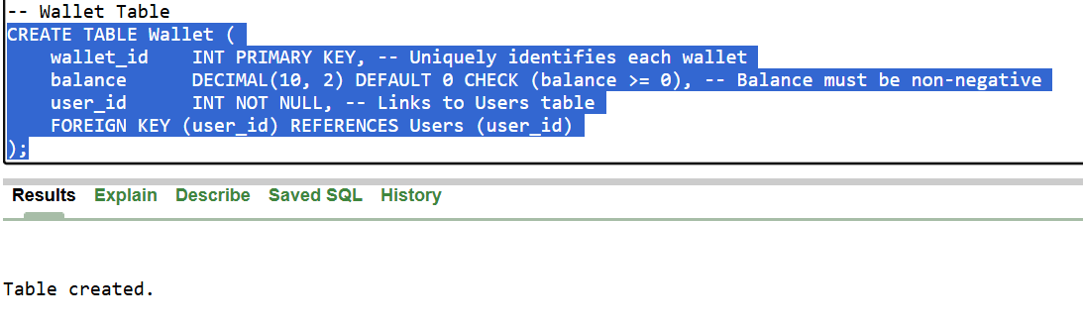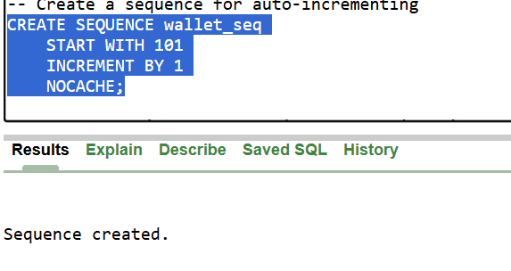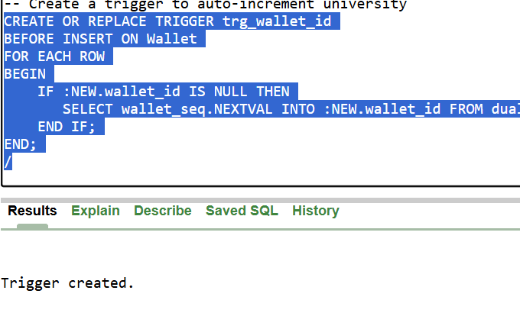

1. **Documents Table**

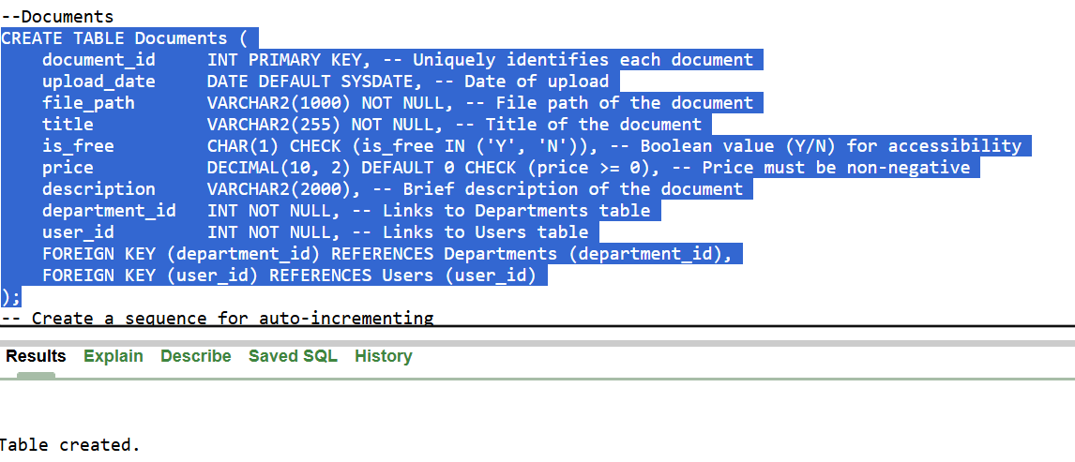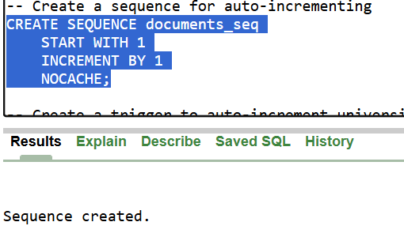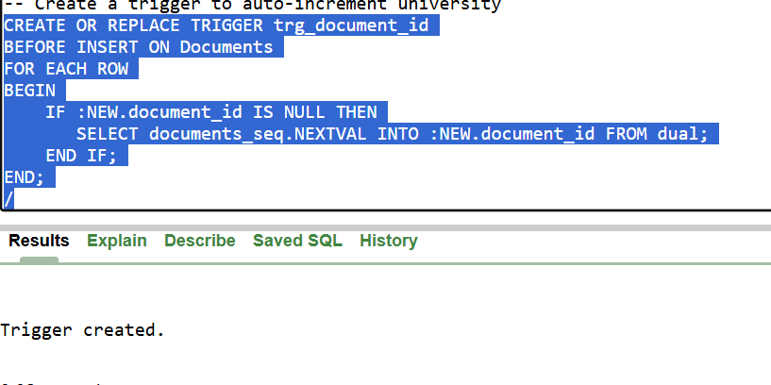

1. **Document_Stats Table**

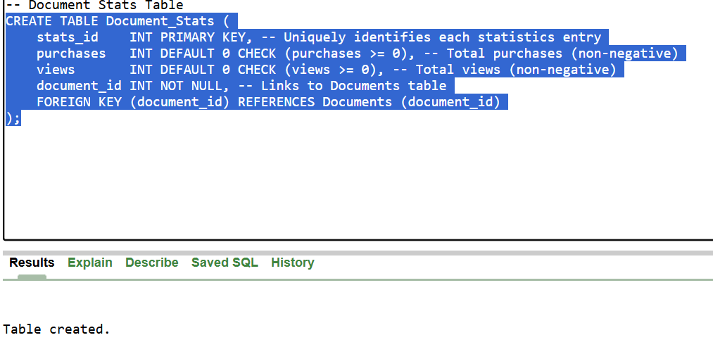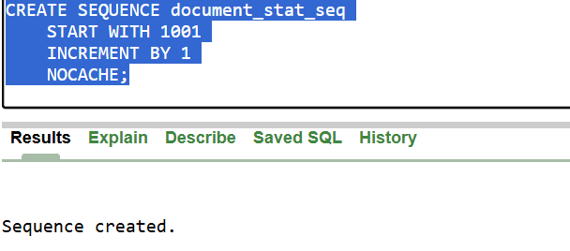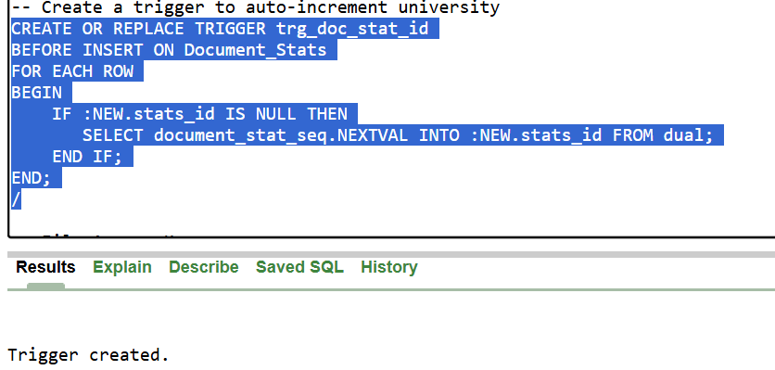

1. **File_Access_Keys Table**

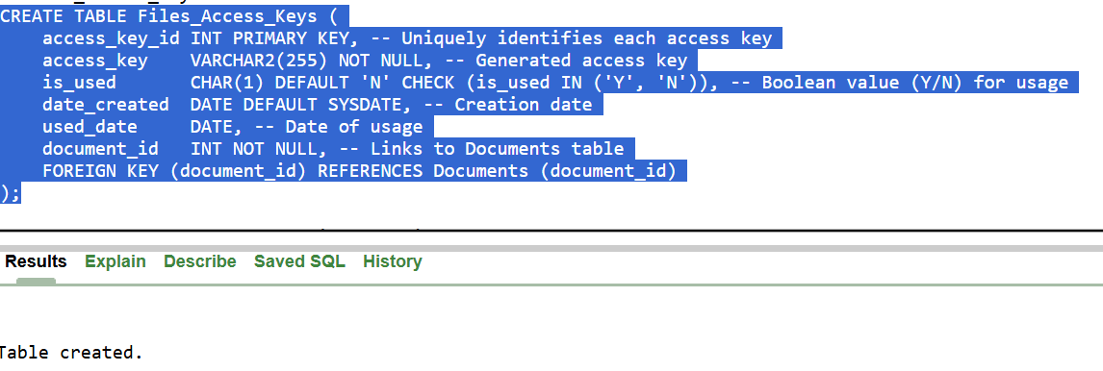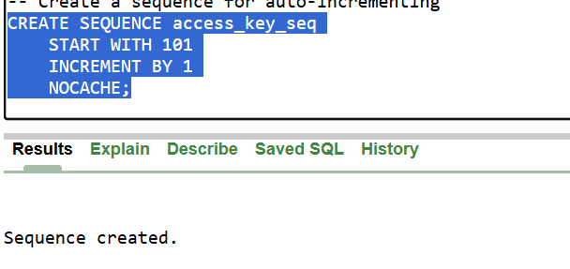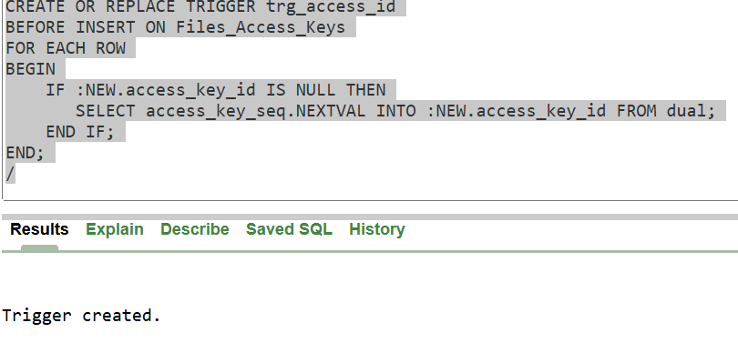

1. **Tags Table**

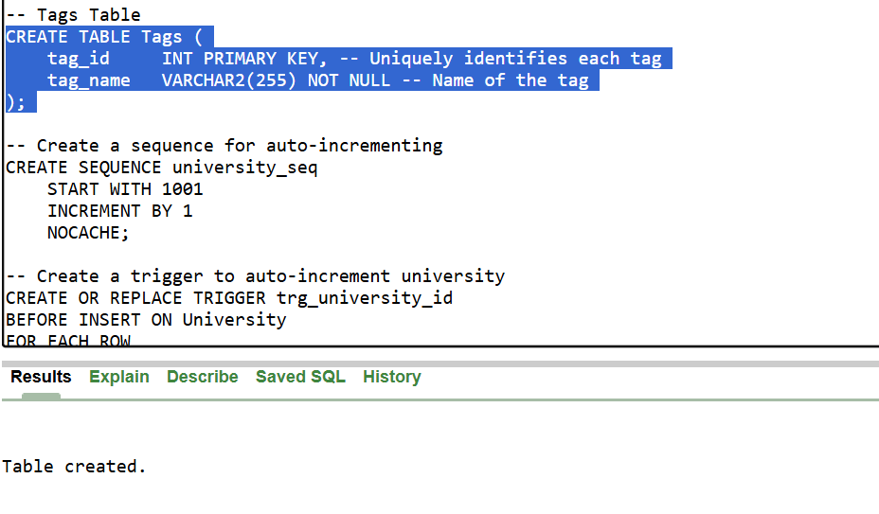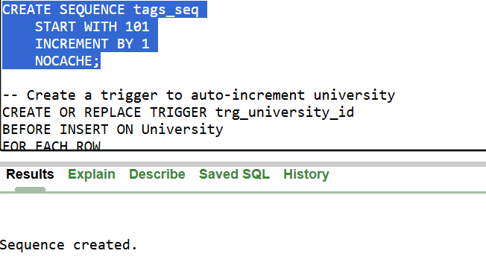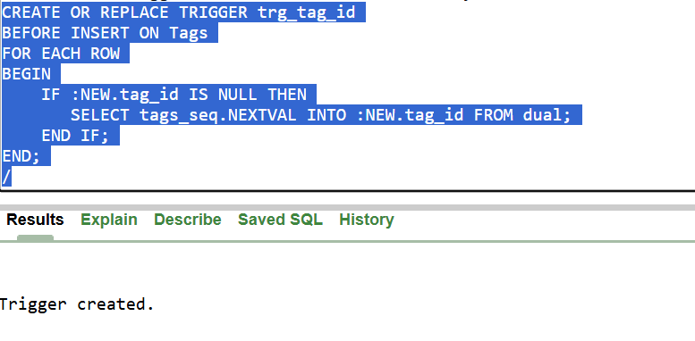

1. **Documet_Tags Table**

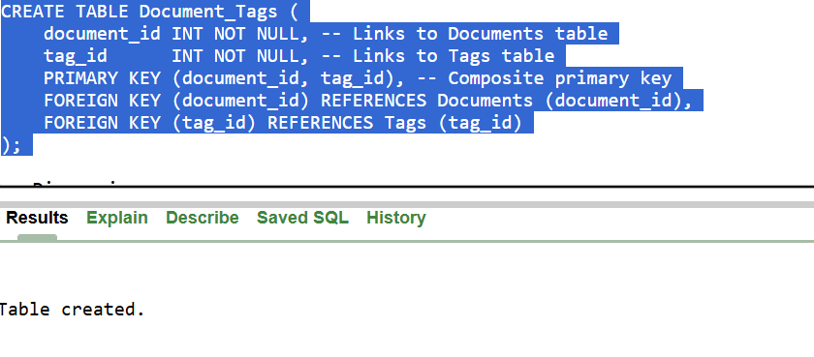

1. **Discussions Table**

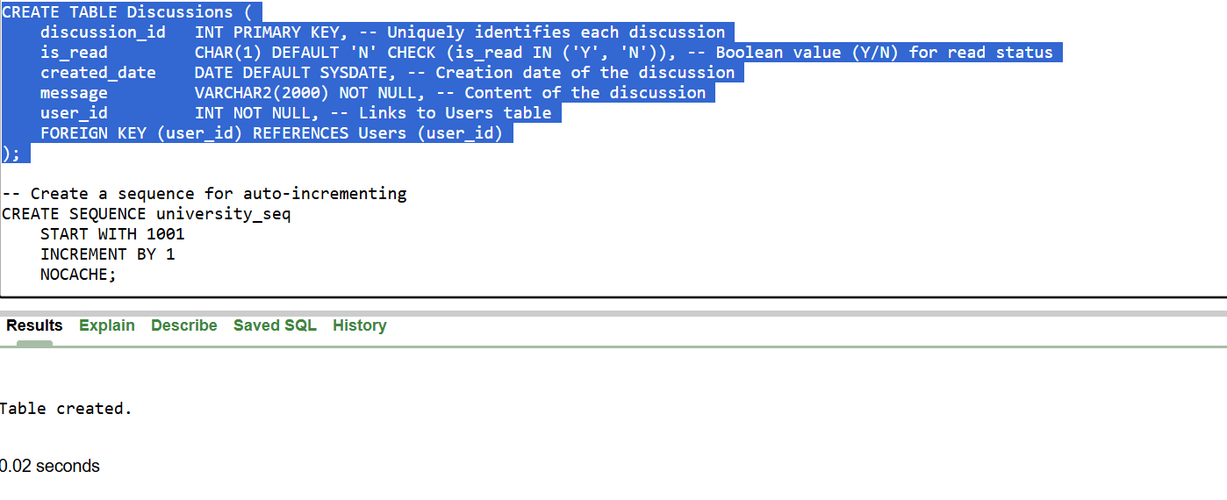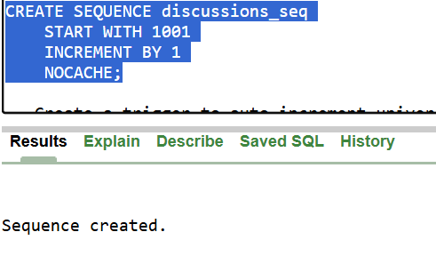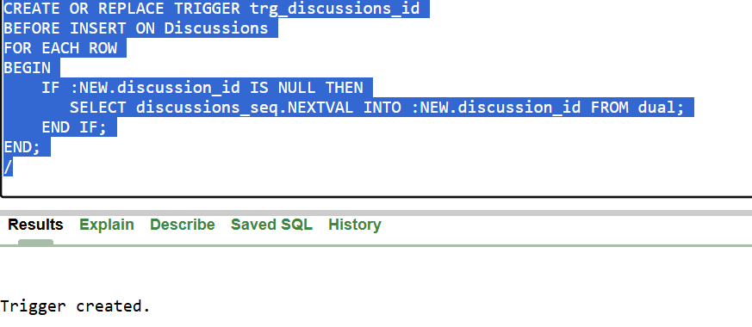

1. **Discussion_Tags Table**

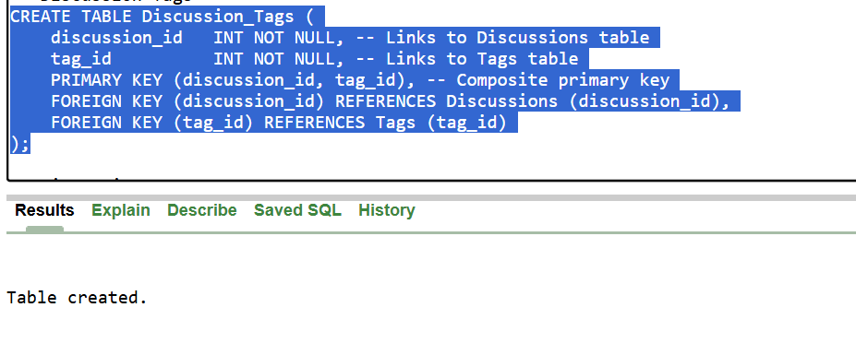

1. **Discussion_Comments Table**

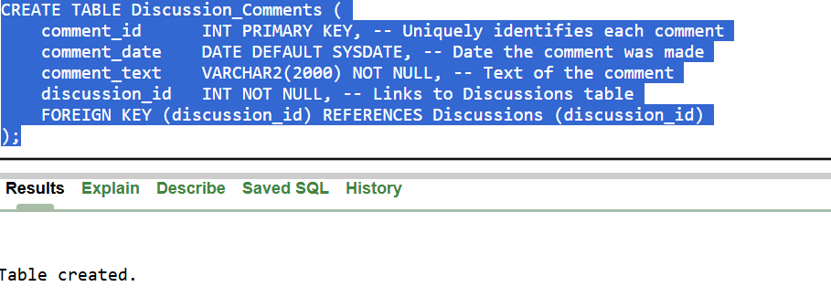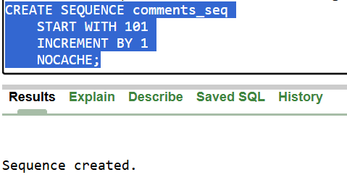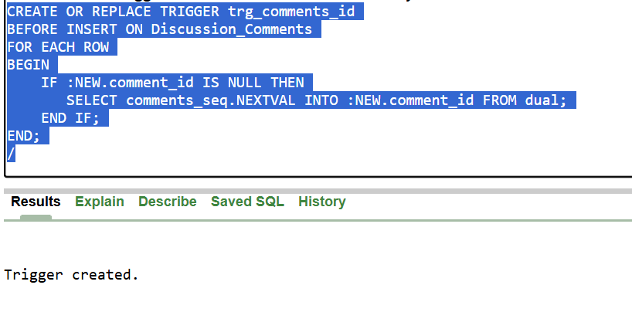

1. **Notifications Table**

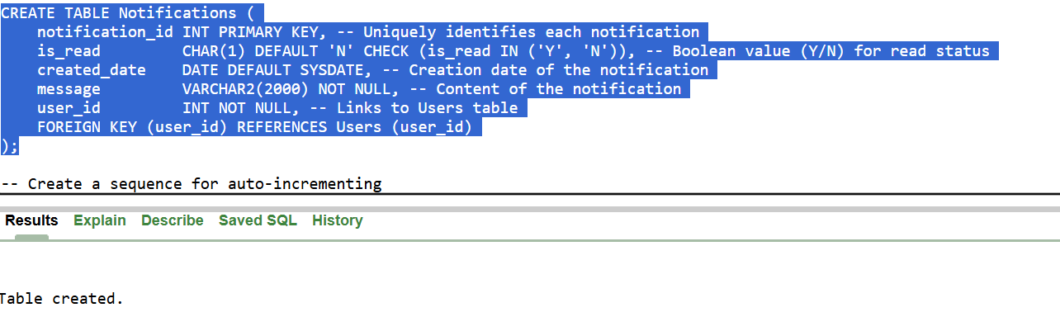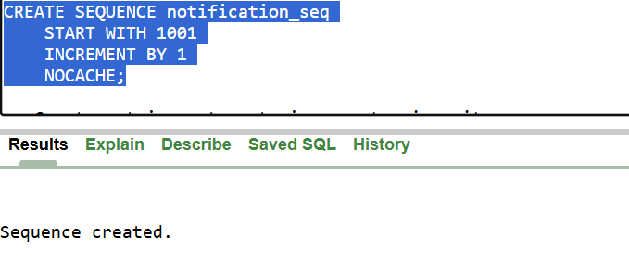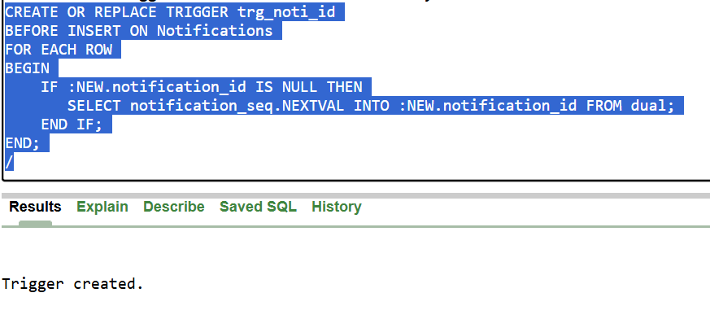

1. **Action_Log Table**

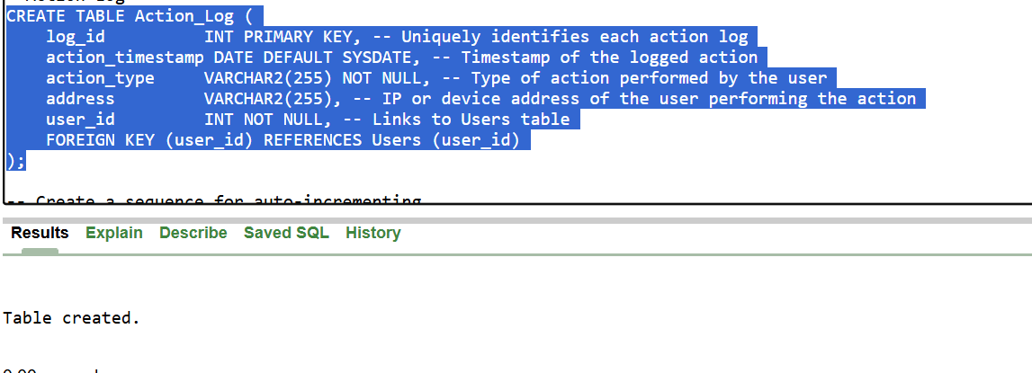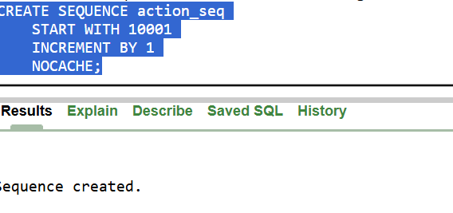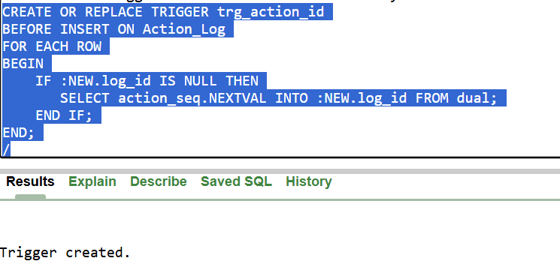

1. **Loans Table**

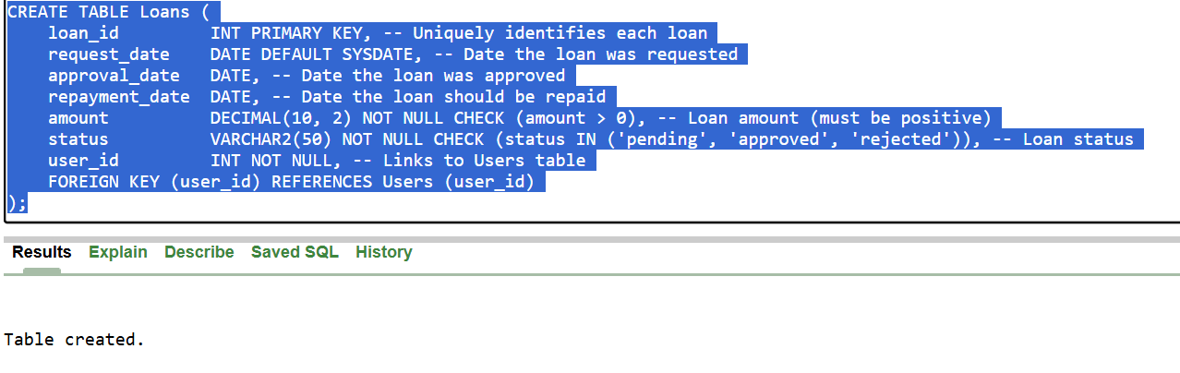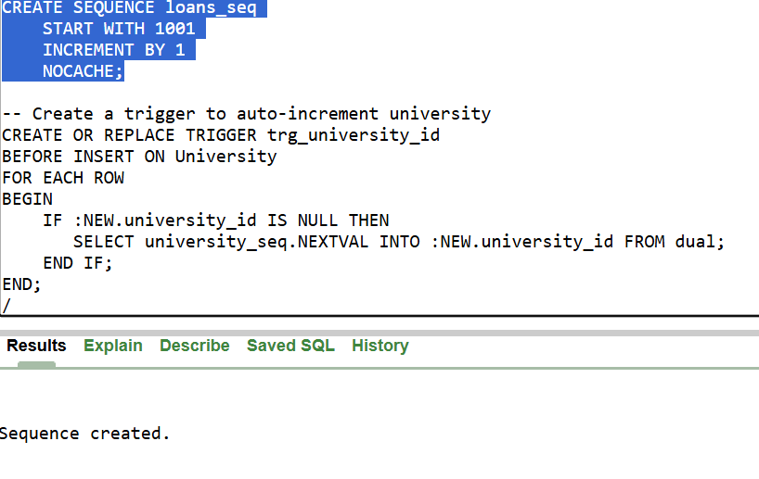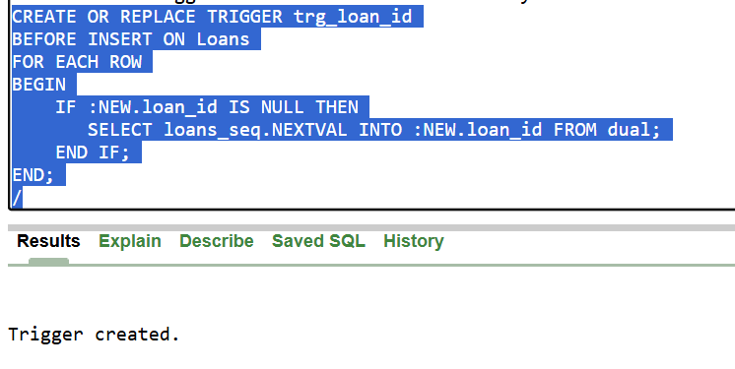

1. **Transactions Table**

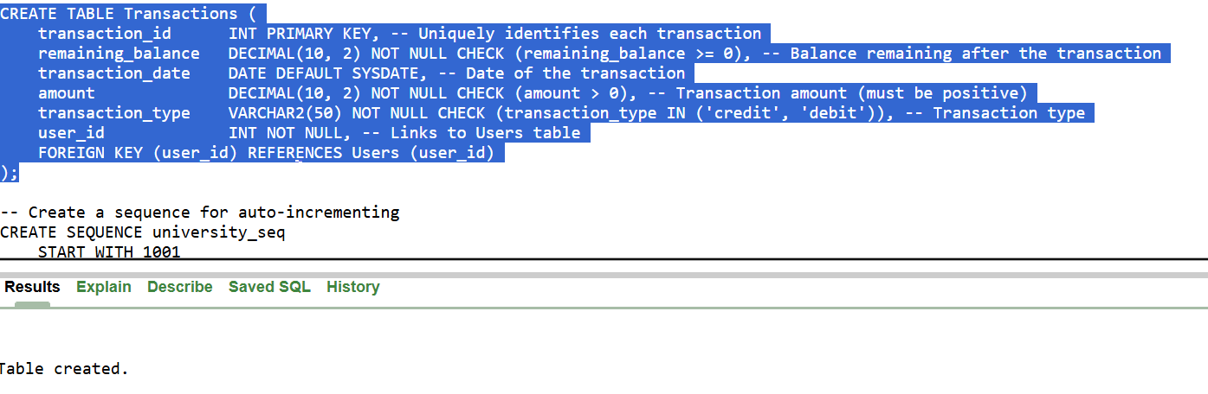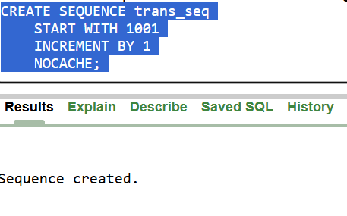

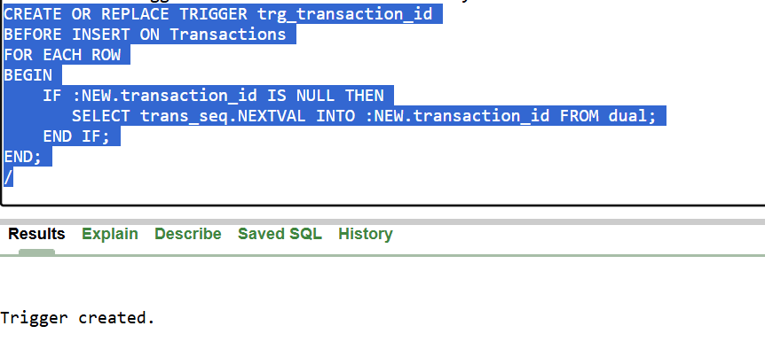

1. **Code**

|  |
| --- |
| ----Courses Table  CREATE TABLE Courses (  course_id INT PRIMARY KEY, -- Used to identify the course uniquely  course_code VARCHAR2(255) NOT NULL, -- Used for storing the code of course offered  course_name VARCHAR2(255) NOT NULL, -- Used for storing the name of course offered  instructor_name VARCHAR2(255) NOT NULL, -- Used for storing the name of instructor teaching the course  academic_year VARCHAR2(255) NOT NULL, -- Used for storing the information of year and semester (e.g fall, spring, summer) of the course offered  semester VARCHAR2(50) NOT NULL -- Used for storing the Semester in which the course is offered  );  -- Create a sequence for auto-incrementing  CREATE SEQUENCE courses_seq  START WITH 101  INCREMENT BY 1  NOCACHE;  -- Create a trigger to auto-increment courses  CREATE OR REPLACE TRIGGER trg_course_id  BEFORE INSERT ON Courses  FOR EACH ROW  BEGIN  IF :NEW.course_id IS NULL THEN  SELECT courses_seq.NEXTVAL INTO :NEW.course_id FROM dual;  END IF;  END;  /  -- University Table  CREATE TABLE University (  university_id INT PRIMARY KEY, -- Used to uniquely identify each university  university_name VARCHAR2(255) NOT NULL, -- Used for storing the name of university  campus_location VARCHAR2(255) NOT NULL -- Used for storing the campus location of the university  );  -- Create a sequence for auto-incrementing  CREATE SEQUENCE university_seq  START WITH 1001  INCREMENT BY 1  NOCACHE;  -- Create a trigger to auto-increment university  CREATE OR REPLACE TRIGGER trg_university_id  BEFORE INSERT ON University  FOR EACH ROW  BEGIN  IF :NEW.university_id IS NULL THEN  SELECT university_seq.NEXTVAL INTO :NEW.university_id FROM dual;  END IF;  END;  /  -- Departments  CREATE TABLE Departments (  department_id INT PRIMARY KEY, -- Uniquely identifies each department  department_name VARCHAR2(255) NOT NULL, -- Name of the department  university_id INT NOT NULL, -- Links to University table  FOREIGN KEY (university_id) REFERENCES University (university_id)  );  -- Create a sequence for auto-incrementing  CREATE SEQUENCE departments_seq  START WITH 1  INCREMENT BY 1  NOCACHE;  -- Create a trigger to auto-increment university  CREATE OR REPLACE TRIGGER trg_department_id  BEFORE INSERT ON Departments  FOR EACH ROW  BEGIN  IF :NEW.department_id IS NULL THEN  SELECT departments_seq.NEXTVAL INTO :NEW.department_id FROM dual;  END IF;  END;  /  -- User Tables  CREATE TABLE Users (  user_id INT PRIMARY KEY, -- Uniquely identifies each user  name VARCHAR2(255) NOT NULL, -- Full name of the user  email VARCHAR2(255) NOT NULL CHECK (email LIKE '%@%.edu.pk'), -- Email must contain .edu.pk  age INT CHECK (age >= 18), -- Minimum age is 18  contact_no VARCHAR2(20), -- Contact number  password VARCHAR2(255) NOT NULL, -- Encrypted password  bio VARCHAR2(1000), -- Brief biography  join_date DATE DEFAULT SYSDATE, -- Date the user joined  program VARCHAR2(255), -- Academic program  semester INT CHECK (semester BETWEEN 1 AND 8), -- Semester must be between 1 and 8  department_id INT, -- Links to Departments table  FOREIGN KEY (department_id) REFERENCES Departments (department_id)  );  -- Create a sequence for auto-incrementing  CREATE SEQUENCE user_seq  START WITH 1  INCREMENT BY 1  NOCACHE;  -- Create a trigger to auto-increment university  CREATE OR REPLACE TRIGGER trg_users_id  BEFORE INSERT ON Users  FOR EACH ROW  BEGIN  IF :NEW.user_id IS NULL THEN  SELECT user_seq.NEXTVAL INTO :NEW.user_id FROM dual;  END IF;  END;  /  -- Wallet Table  CREATE TABLE Wallet (  wallet_id INT PRIMARY KEY, -- Uniquely identifies each wallet  balance DECIMAL(10, 2) DEFAULT 0 CHECK (balance >= 0), -- Balance must be non-negative  user_id INT NOT NULL, -- Links to Users table  FOREIGN KEY (user_id) REFERENCES Users (user_id)  );  -- Create a sequence for auto-incrementing  CREATE SEQUENCE wallet_seq  START WITH 101  INCREMENT BY 1  NOCACHE;  -- Create a trigger to auto-increment university  CREATE OR REPLACE TRIGGER trg_wallet_id  BEFORE INSERT ON Wallet  FOR EACH ROW  BEGIN  IF :NEW.wallet_id IS NULL THEN  SELECT wallet_seq.NEXTVAL INTO :NEW.wallet_id FROM dual;  END IF;  END;  /  --Documents  CREATE TABLE Documents (  document_id INT PRIMARY KEY, -- Uniquely identifies each document  upload_date DATE DEFAULT SYSDATE, -- Date of upload  file_path VARCHAR2(1000) NOT NULL, -- File path of the document  title VARCHAR2(255) NOT NULL, -- Title of the document  is_free CHAR(1) CHECK (is_free IN ('Y', 'N')), -- Boolean value (Y/N) for accessibility  price DECIMAL(10, 2) DEFAULT 0 CHECK (price >= 0), -- Price must be non-negative  description VARCHAR2(2000), -- Brief description of the document  department_id INT NOT NULL, -- Links to Departments table  user_id INT NOT NULL, -- Links to Users table  FOREIGN KEY (department_id) REFERENCES Departments (department_id),  FOREIGN KEY (user_id) REFERENCES Users (user_id)  );  -- Create a sequence for auto-incrementing  CREATE SEQUENCE documents_seq  START WITH 1  INCREMENT BY 1  NOCACHE;  -- Create a trigger to auto-increment university  CREATE OR REPLACE TRIGGER trg_document_id  BEFORE INSERT ON Documents  FOR EACH ROW  BEGIN  IF :NEW.document_id IS NULL THEN  SELECT documents_seq.NEXTVAL INTO :NEW.document_id FROM dual;  END IF;  END;  /  -- Document Stats Table  CREATE TABLE Document_Stats (  stats_id INT PRIMARY KEY, -- Uniquely identifies each statistics entry  purchases INT DEFAULT 0 CHECK (purchases >= 0), -- Total purchases (non-negative)  views INT DEFAULT 0 CHECK (views >= 0), -- Total views (non-negative)  document_id INT NOT NULL, -- Links to Documents table  FOREIGN KEY (document_id) REFERENCES Documents (document_id)  );  -- Create a sequence for auto-incrementing  CREATE SEQUENCE document_stat_seq  START WITH 1001  INCREMENT BY 1  NOCACHE;  -- Create a trigger to auto-increment university  CREATE OR REPLACE TRIGGER trg_doc_stat_id  BEFORE INSERT ON Document_Stats  FOR EACH ROW  BEGIN  IF :NEW.stats_id IS NULL THEN  SELECT document_stat_seq.NEXTVAL INTO :NEW.stats_id FROM dual;  END IF;  END;  /  -- File_Access_Keys  CREATE TABLE Files_Access_Keys (  access_key_id INT PRIMARY KEY, -- Uniquely identifies each access key  access_key VARCHAR2(255) NOT NULL, -- Generated access key  is_used CHAR(1) DEFAULT 'N' CHECK (is_used IN ('Y', 'N')), -- Boolean value (Y/N) for usage  date_created DATE DEFAULT SYSDATE, -- Creation date  used_date DATE, -- Date of usage  document_id INT NOT NULL, -- Links to Documents table  FOREIGN KEY (document_id) REFERENCES Documents (document_id)  );  -- Create a sequence for auto-incrementing  CREATE SEQUENCE access_key_seq  START WITH 101  INCREMENT BY 1  NOCACHE;  -- Create a trigger to auto-increment university  CREATE OR REPLACE TRIGGER trg_access_id  BEFORE INSERT ON Files_Access_Keys  FOR EACH ROW  BEGIN  IF :NEW.access_key_id IS NULL THEN  SELECT access_key_seq.NEXTVAL INTO :NEW.access_key_id FROM dual;  END IF;  END;  /  -- Tags Table  CREATE TABLE Tags (  tag_id INT PRIMARY KEY, -- Uniquely identifies each tag  tag_name VARCHAR2(255) NOT NULL -- Name of the tag  );  -- Create a sequence for auto-incrementing  CREATE SEQUENCE tags_seq  START WITH 101  INCREMENT BY 1  NOCACHE;  -- Create a trigger to auto-increment university  CREATE OR REPLACE TRIGGER trg_tag_id  BEFORE INSERT ON Tags  FOR EACH ROW  BEGIN  IF :NEW.tag_id IS NULL THEN  SELECT tags_seq.NEXTVAL INTO :NEW.tag_id FROM dual;  END IF;  END;  /  -- Document Tags Table  CREATE TABLE Document_Tags (  document_id INT NOT NULL, -- Links to Documents table  tag_id INT NOT NULL, -- Links to Tags table  PRIMARY KEY (document_id, tag_id), -- Composite primary key  FOREIGN KEY (document_id) REFERENCES Documents (document_id),  FOREIGN KEY (tag_id) REFERENCES Tags (tag_id)  );  -- Discussions  CREATE TABLE Discussions (  discussion_id INT PRIMARY KEY, -- Uniquely identifies each discussion  is_read CHAR(1) DEFAULT 'N' CHECK (is_read IN ('Y', 'N')), -- Boolean value (Y/N) for read status  created_date DATE DEFAULT SYSDATE, -- Creation date of the discussion  message VARCHAR2(2000) NOT NULL, -- Content of the discussion  user_id INT NOT NULL, -- Links to Users table  FOREIGN KEY (user_id) REFERENCES Users (user_id)  );  -- Create a sequence for auto-incrementing  CREATE SEQUENCE discussions_seq  START WITH 1001  INCREMENT BY 1  NOCACHE;  -- Create a trigger to auto-increment university  CREATE OR REPLACE TRIGGER trg_discussions_id  BEFORE INSERT ON Discussions  FOR EACH ROW  BEGIN  IF :NEW.discussion_id IS NULL THEN  SELECT discussions_seq.NEXTVAL INTO :NEW.discussion_id FROM dual;  END IF;  END;  /  -- Discussion Tags  CREATE TABLE Discussion_Tags (  discussion_id INT NOT NULL, -- Links to Discussions table  tag_id INT NOT NULL, -- Links to Tags table  PRIMARY KEY (discussion_id, tag_id), -- Composite primary key  FOREIGN KEY (discussion_id) REFERENCES Discussions (discussion_id),  FOREIGN KEY (tag_id) REFERENCES Tags (tag_id)  );  -- Discussion Comments  CREATE TABLE Discussion_Comments (  comment_id INT PRIMARY KEY, -- Uniquely identifies each comment  comment_date DATE DEFAULT SYSDATE, -- Date the comment was made  comment_text VARCHAR2(2000) NOT NULL, -- Text of the comment  discussion_id INT NOT NULL, -- Links to Discussions table  FOREIGN KEY (discussion_id) REFERENCES Discussions (discussion_id)  );  -- Create a sequence for auto-incrementing  CREATE SEQUENCE comments_seq  START WITH 101  INCREMENT BY 1  NOCACHE;  -- Create a trigger to auto-increment university  CREATE OR REPLACE TRIGGER trg_comments_id  BEFORE INSERT ON Discussion_Comments  FOR EACH ROW  BEGIN  IF :NEW.comment_id IS NULL THEN  SELECT comments_seq.NEXTVAL INTO :NEW.comment_id FROM dual;  END IF;  END;  /  -- Notifications Table  CREATE TABLE Notifications (  notification_id INT PRIMARY KEY, -- Uniquely identifies each notification  is_read CHAR(1) DEFAULT 'N' CHECK (is_read IN ('Y', 'N')), -- Boolean value (Y/N) for read status  created_date DATE DEFAULT SYSDATE, -- Creation date of the notification  message VARCHAR2(2000) NOT NULL, -- Content of the notification  user_id INT NOT NULL, -- Links to Users table  FOREIGN KEY (user_id) REFERENCES Users (user_id)  );  -- Create a sequence for auto-incrementing  CREATE SEQUENCE notification_seq  START WITH 1001  INCREMENT BY 1  NOCACHE;  -- Create a trigger to auto-increment university  CREATE OR REPLACE TRIGGER trg_noti_id  BEFORE INSERT ON Notifications  FOR EACH ROW  BEGIN  IF :NEW.notification_id IS NULL THEN  SELECT notification_seq.NEXTVAL INTO :NEW.notification_id FROM dual;  END IF;  END;  /  --Action Log  CREATE TABLE Action_Log (  log_id INT PRIMARY KEY, -- Uniquely identifies each action log  action_timestamp DATE DEFAULT SYSDATE, -- Timestamp of the logged action  action_type VARCHAR2(255) NOT NULL, -- Type of action performed by the user  address VARCHAR2(255), -- IP or device address of the user performing the action  user_id INT NOT NULL, -- Links to Users table  FOREIGN KEY (user_id) REFERENCES Users (user_id)  );  -- Create a sequence for auto-incrementing  CREATE SEQUENCE action_seq  START WITH 10001  INCREMENT BY 1  NOCACHE;  -- Create a trigger to auto-increment university  CREATE OR REPLACE TRIGGER trg_action_id  BEFORE INSERT ON Action_Log  FOR EACH ROW  BEGIN  IF :NEW.log_id IS NULL THEN  SELECT action_seq.NEXTVAL INTO :NEW.log_id FROM dual;  END IF;  END;  /  -- Loans Table  CREATE TABLE Loans (  loan_id INT PRIMARY KEY, -- Uniquely identifies each loan  request_date DATE DEFAULT SYSDATE, -- Date the loan was requested  approval_date DATE, -- Date the loan was approved  repayment_date DATE, -- Date the loan should be repaid  amount DECIMAL(10, 2) NOT NULL CHECK (amount > 0), -- Loan amount (must be positive)  status VARCHAR2(50) NOT NULL CHECK (status IN ('pending', 'approved', 'rejected')), -- Loan status  user_id INT NOT NULL, -- Links to Users table  FOREIGN KEY (user_id) REFERENCES Users (user_id)  );  -- Create a sequence for auto-incrementing  CREATE SEQUENCE loans_seq  START WITH 1001  INCREMENT BY 1  NOCACHE;  -- Create a trigger to auto-increment university  CREATE OR REPLACE TRIGGER trg_loan_id  BEFORE INSERT ON Loans  FOR EACH ROW  BEGIN  IF :NEW.loan_id IS NULL THEN  SELECT loans_seq.NEXTVAL INTO :NEW.loan_id FROM dual;  END IF;  END;  /  -- Transactions Table  CREATE TABLE Transactions (  transaction_id INT PRIMARY KEY, -- Uniquely identifies each transaction  remaining_balance DECIMAL(10, 2) NOT NULL CHECK (remaining_balance >= 0), -- Balance remaining after the transaction  transaction_date DATE DEFAULT SYSDATE, -- Date of the transaction  amount DECIMAL(10, 2) NOT NULL CHECK (amount > 0), -- Transaction amount (must be positive)  transaction_type VARCHAR2(50) NOT NULL CHECK (transaction_type IN ('credit', 'debit')), -- Transaction type  user_id INT NOT NULL, -- Links to Users table  FOREIGN KEY (user_id) REFERENCES Users (user_id)  );  -- Create a sequence for auto-incrementing  CREATE SEQUENCE trans_seq  START WITH 1001  INCREMENT BY 1  NOCACHE;  -- Create a trigger to auto-increment university  CREATE OR REPLACE TRIGGER trg_transaction_id  BEFORE INSERT ON Transactions  FOR EACH ROW  BEGIN  IF :NEW.transaction_id IS NULL THEN  SELECT trans_seq.NEXTVAL INTO :NEW.transaction_id FROM dual;  END IF;  END;  / |